Software Design Specification

CHATBOT

Project Code:
#CB343827

Internal Advisor:
Saad Razzaq

External Advisor:

Project Manager:
Dr. Muhammad Ilyas

Project Team:

Muzammal Fiaz BSEF19M034 (Team Lead)
Ayesha BSEF19M038 (Team Member)
Zain ul Abidin BSEF19M027 (Team Member)

Submission Date:
12-12-22

_____________________
Project Manager’s Signature

Document Information

Category | Information
Customer | Department of CS & IT
Project | Chatbot
Document | Software Design Specification
Document Version | 2.0
Identifier | <PGBH01-2022-DS>
Status | Final
Author(s) | <Names of all the authors of this document>
Approver(s) | PM
Issue Date | Sept. 15, 2022
Document Location
Distribution | - Advisor  - PM  - Project Office

Definition of Terms, Acronyms and Abbreviations
.

Term | Description
ASP | Active Server Pages
RS | Requirements Specifications
OS | Operating System
GUI | Graphic User Interface
DB | Database
SU | Sargodha University

Table of Contents

1. Introduction 4
1.1 Purpose of Document 4
1.2 Project Overview 4
1.3 Scope 4
2. Design Considerations 4
2.1 Assumptions and Dependencies 4
2.2 Risks and Volatile Areas 5
3. System Architecture 6
3.1 Sub-System / Component / Module Level Architecture / Sub-component 7
4. Design Strategies 11
5. Detailed System Design 12
6. References 19

s

Introduction

  - Purpose of Document
The system design is sufficiently described in this software design document to allow development to move forward knowing exactly what has to be built and how it should be done. It will give a thorough description of the Chatbot's design. This document's goal is to offer graphical documentation of the project's software design, including sequence diagrams, collaboration models, use case models, data flow models, and other supporting requirement data.

  - Project Overview

Making a chatbot that can respond to inquiries about admissions and other pertinent topics is the goal. Users will be able to engage with the system via a web interface to find answers to their questions, as well as through a management interface. Anyone can use the website, participate in conversations, and obtain admission details. He can also rate the system on a scale of 1 to 5, with 1 being poor and 5 being exceptional, to provide input. It will be possible for the system administrator to add, amend, and remove questions and answers. He will also be able to see the user-provided comments. A few security-related considerations also need to be taken into account.

  - Scope
The objective is to give users a quick and simple way to get their queries addressed as well as to give other developers the tools they need to include Chatbot in their business. It will address the queries of the users related to admissions, courses, events, etc. our system answers limited questions that we include in our database. Our system will notify those questions that are not included in the DB so the admin can update the DB. Our system will not address all the queries of the user, it will answer limited questions. If it could not address the query in that case the system will generate an apology response to the user.

Design Considerations

The objective of the design phase is to convert the requirements into a structure that can be implemented in some programming languages and is described in the SRS document. Technically speaking, throughout the design phase, the software architecture is derived from the SRS document. Here, the chatbot's design is crucial; it needs to be excellent. It must function flawlessly—ideally, the recipient should think they are speaking to a human.
.

  - Assumptions and Dependencies

List of assumed factors that could affect the stated requirements.
- The user must have a mobile or PC to access the application.
- The user must have an active internet connection.
- There can be multiple clients.
- It is assumed that the user can easily learn the system.
- The details related to our task were manually added.
- Users can read and understand the answer to their queries easily.
- Chatbot is internet dependent.

  - Risks and Volatile Areas
Components  Categories |  | Performance | Support | Cost | Schedule
Catastrophic | 1. | Data security risk is also involved. If the chatbot is deployed in non-encrypted platform, the data can be hijacked. |  | Failure results in a breach of user privacy and a Rs. 10,000 budget overrun.
Catastrophic | 2. | Does not show appropriate results to users query, There could be an integrity breach or the system could stop responding. | No responsive and unsupportable | Significant financial shortages, budget overrun likely | Unachievable
Critical | 1.  2. | If a chatbot cannot utilize Artificial Intelligence and Natural Language Processing, it will fail.  Because network size and capacity will be so important, there is a risk of inconsistent performance. Insufficient testing could put the performance of the website at risk. |  | There could be a technical issue or the bot might not be programmed to answer the user's query.  Inadequate user satisfaction and experience and a Rs. 8,000 budget overrun.
Critical | 2. | System responses to user queries were incorrect.  Users might stop using the system if the system responds incorrectly. | Minor delay in software modulation | Some financial shortages, possible budget overrun | potential slippage
Marginal | 1. | A significant risk exists when using improper tools and languages that cannot be integrated with the website. |  | Cost impact and recoverable schedule slips with expected value of Rs.3k to 5k.
Marginal | 2. | Misunderstanding the quires and doesn’t support | Responsive support | To some extent financial shortages, possible budget overrun | Realistic achievable
Negligible | 1. | lacking the ability to comprehend the context of the conversation |  | Results in minor cost and schedule impact with expected value of Rs. 2k or less
Negligible | 2. | This can involve making errors or failing to complete tasks correctly. | Easily supportable | Possible budget underrun | Early achievable

System Architecture

An architecture description is a formal description and representation of a system that supports the logic and response of the system. The graphic depicts the system's architectural layout, which includes a chatbot that links the user to the database and finds the answer to the user's query. A system architecture is a representation of a system that maps the functionality of hardware and software components, the architectures of these components, and the user's interaction with those components.
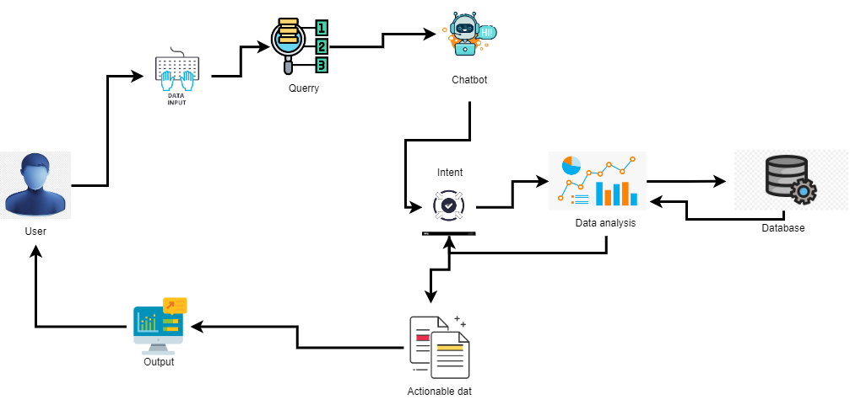
Fig 3: Context Diagram of System Architecture

  - Sub-System / Component / Module Level Architecture / Sub-component

Front End Application:
It will be a web app which receives question from the
User and talks to the Chatbot API Service to give the answer.
Chatbot API Service:
It will receive HTTP GET requests containing user queries and should
Forward them to Chatbot Main.
Chatbot Main:
Main process is called by the API, which coordinates the other
Subsystems.
Generic Question Construction:
It will take the question from the user, and creates a
Generic question template by replacing certain nouns with generic representations.
Generic Answer Construction:
It takes in a generic question template and provides output in the form of generic answer template.
Generic Answer Comparison:
It takes a generic answer template and make comparison with
Information from the database to form an answer.

Error Handler:
If an error occurs during execution of the system, the system will throw an exception and it will be up to error handler to decide how to respond to users.
Database:
Database will store information that is needed by needed by generic question construction and generic answer comparison.

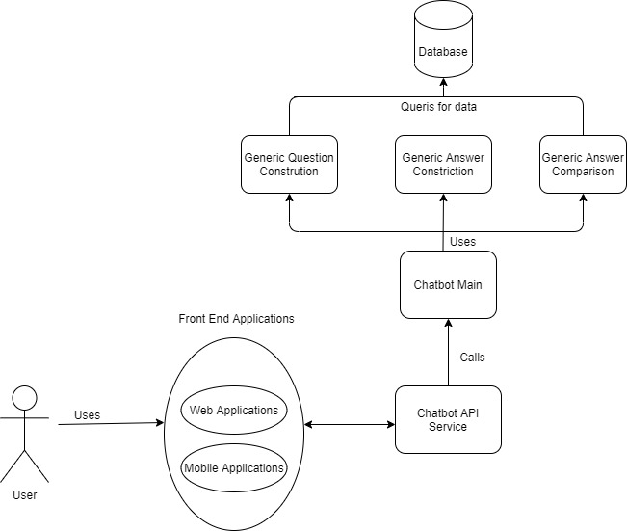

Use Case Diagram

Chatbot API Service

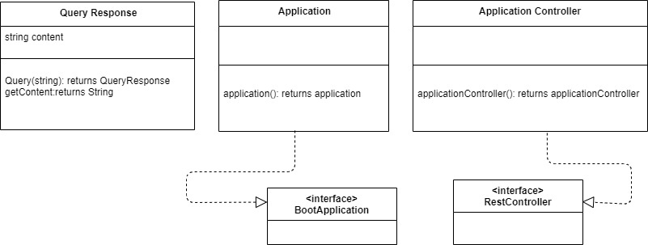

Chatbot Main

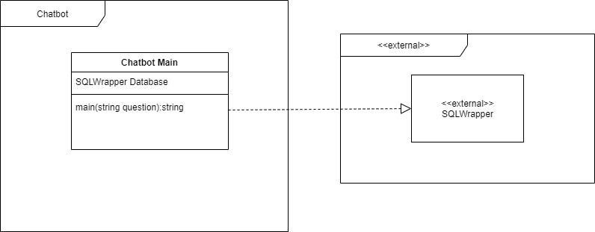

Generic Question Construction

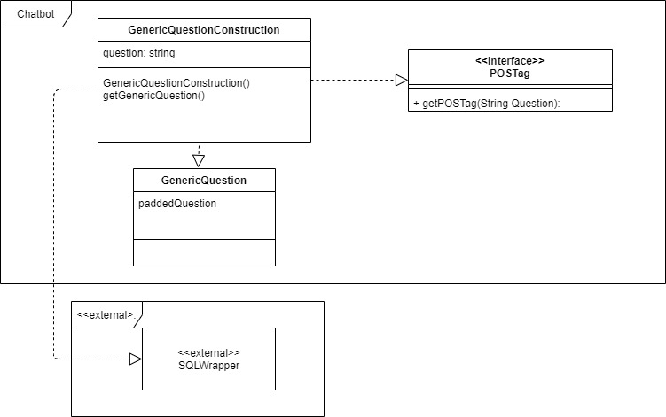
Generic Answer Construction

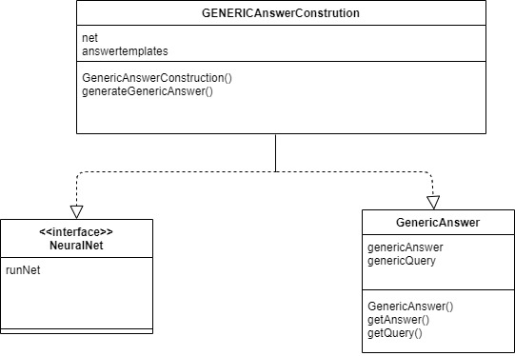

Generic Answer Comparison

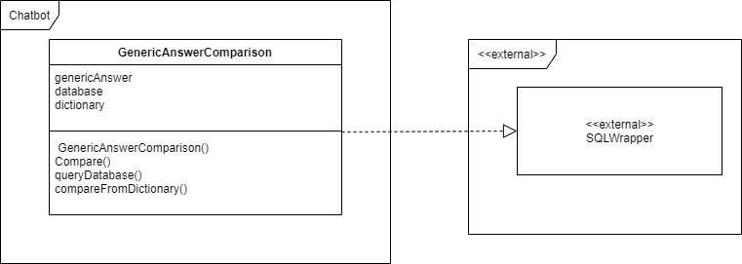

Error Handler

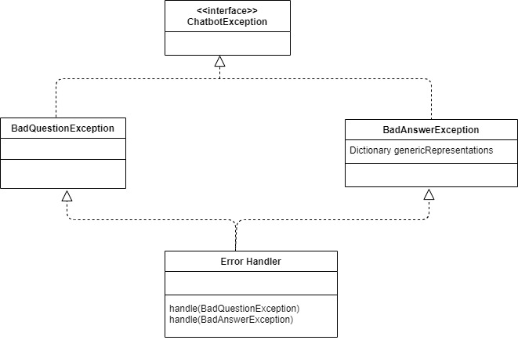

Design Strategies
This chatbot design provide an excellent user experience and interactive user interface. It should be easy to use and deliver some value to the user that they would not get from a conventional chatbot design and integrate data together to enhance the customer experiences. This chatbot especially design for the university website visitor. We will focus to develop the chatbot according to users’ requirements. Design strategies includes
- Future system extension and enhancement
- Reusability of the system
- Well design user interface
- Fast response by the system
- Strong data protection
- Excellent user support

4.1 Design paradigm

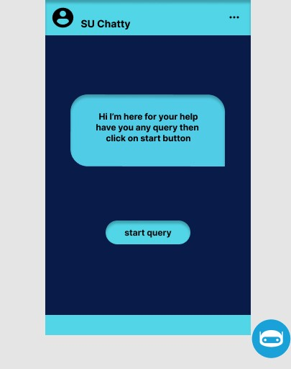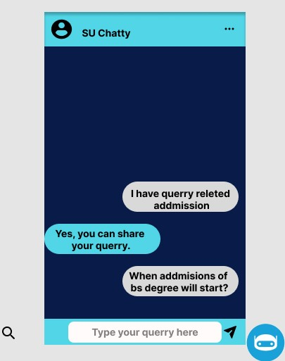

Detailed System Design
A detailed design should include the following:

  - DFD (0 LEVEL / CONTEXT LEVEL)

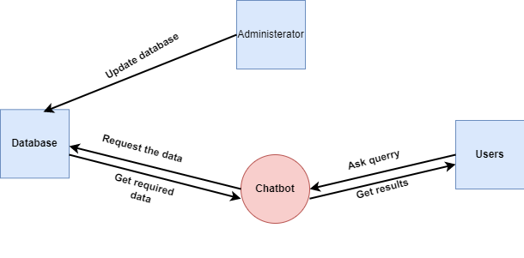

DFD ( 1 LEVEL)
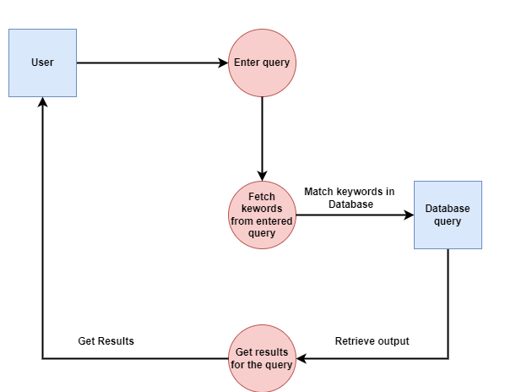

  - USE CASE DIAGRAM
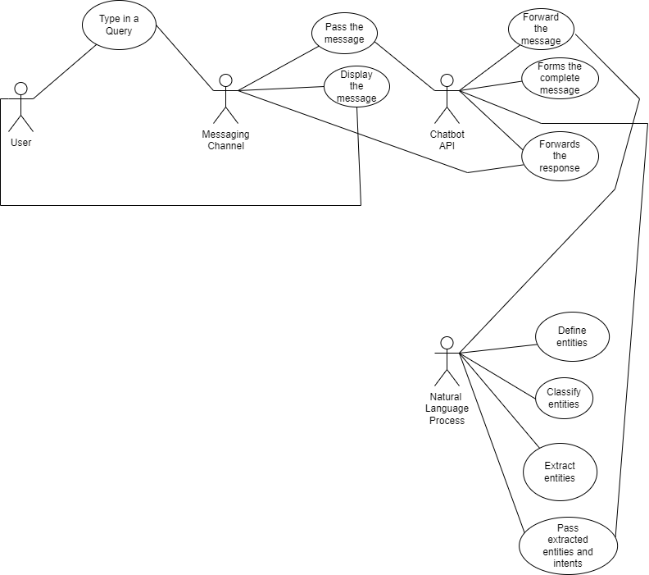

  - SEQUENCE DIAGRAM
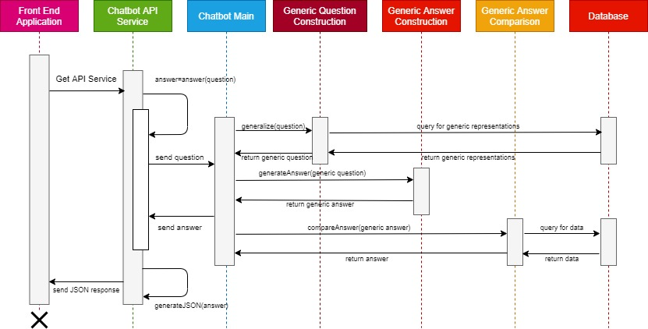

  - ER DIAGRAM

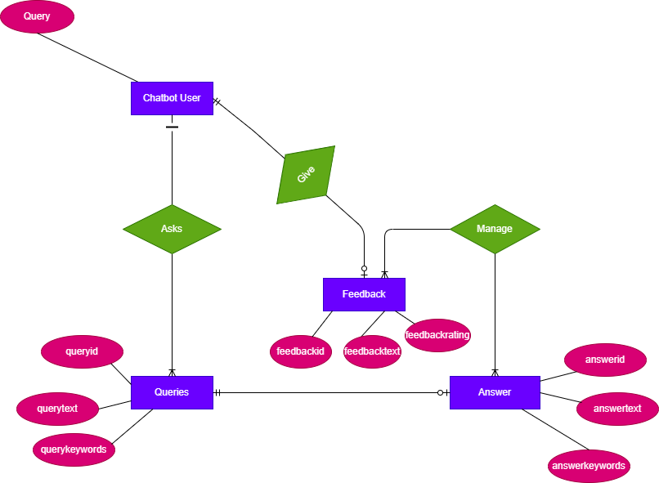

  - System Architecture
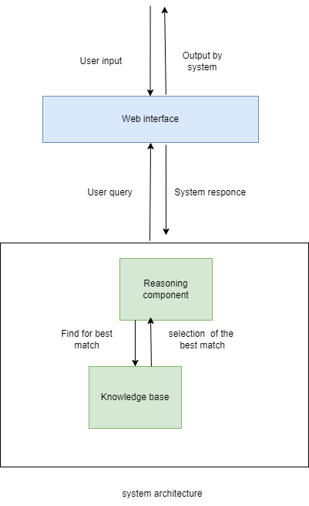
  - Flow chart
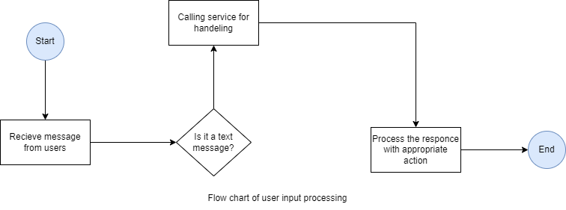

  - Class Diagram

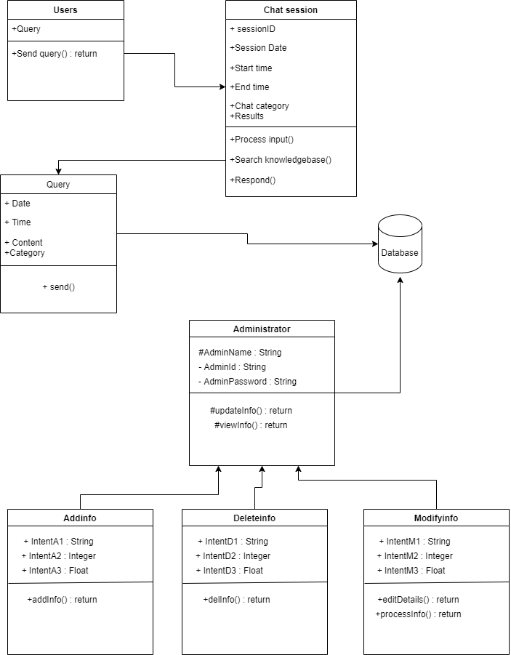

References
- (n.d.). Retrieved from studocu: https://www.studocu.com/row/document/uganda-christian-university/information-systems/system-requirement-document/5379091
- Kasasira. (2021). Retrieved from Studocu: https://www.studocu.com/row/document/uganda-christian-university/information-systems/system-requirement-document/5379091
- Polatidis, N. (n.d.). Retrieved from https://www.coursehero.com/file/74709119/Chatbot-for-admissionspdf/
- Rahman, A. (2020, April). Retrieved from https://idoc.pub/documents/afr-chatbot-srs-document-d49oqg228049
- (2020)

